# Assignment -3

Python Programming

|  |  |
| --- | --- |
| Assignment Date | 19 September 2022 |
| Student Name | NIRANJAN RAJ M |
| Student Roll Number | 19EC041 |
| Maximum Marks | 2 Marks |

# Question-1:

Write a python program to test a given number is prime or not.

# Solution:

num=int(input ("Enter your value:")) print(num)

# If given number is greater than 1

if num>1:

# Iterate from 2 to n / 2

for i in range(2, int(num/2)+1):

# If num is divisible by any number between # 2 and n / 2, it is not prime

if (num % i) == 0:

print(num, "is not a prime number") break

else: else:

print (num, "is a prime number") print (num, "is not a prime number")

# Output:

Enter your value: 7 7

7 is a prime number.

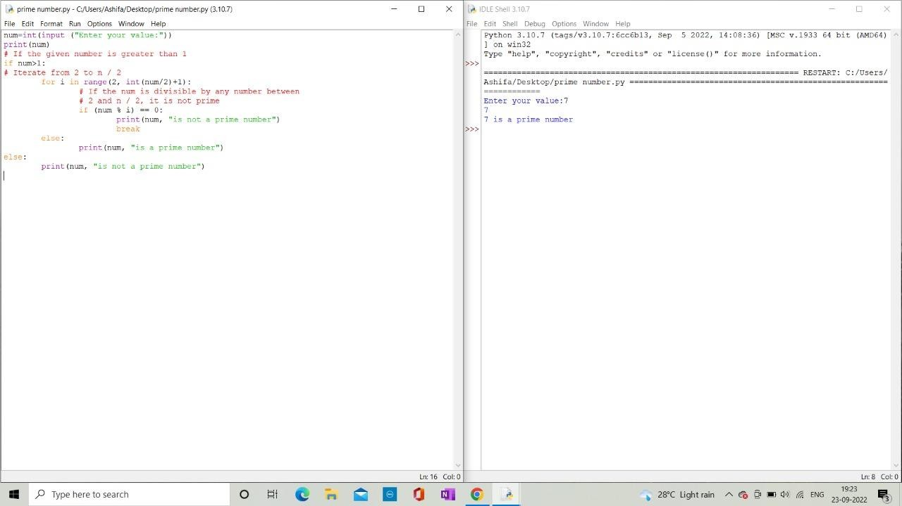

# Question-2:

Write a program to generate odd numbers from m to n using while loop.

# Solution:

# Python program to print odd Numbers

m=int(input("Enter the m value:")) n=int(input("Enter the n value:"))

for num in range(m,n+1):

while(num%2!=0): print(num) break

# Output:

Enter the m value:1 Enter the n value:10 1

3

5

7

9

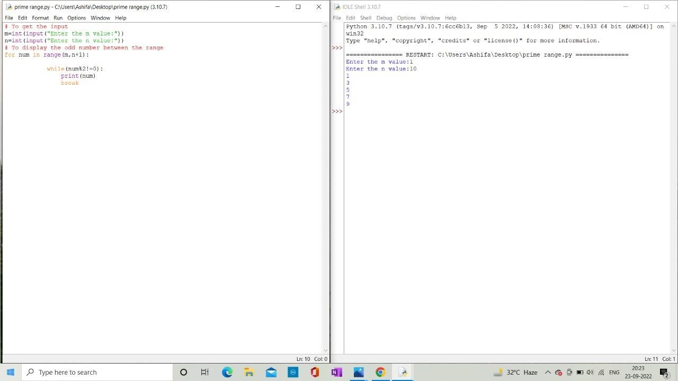

# Question-3:

Write a python program to display prime number series up to given number.

# Solution:

# Python program to display all the prime numbers within an interval

lower = int(input("Please Enter minimum value:")) upper = int(input("Please Enter maximum value:"))

print("Prime numbers between", lower, "and", upper, "are:") for num in range(lower, upper + 1):

# all prime numbers are greater than 1

if num > 1:

for i in range(2, num): if (num % i) == 0:

break else:

print(num)

# Output:

Please Enter Starting Value:3 Please Enter Ending Value:11

Prime number between 3 and 11 are: 3

5

7

11

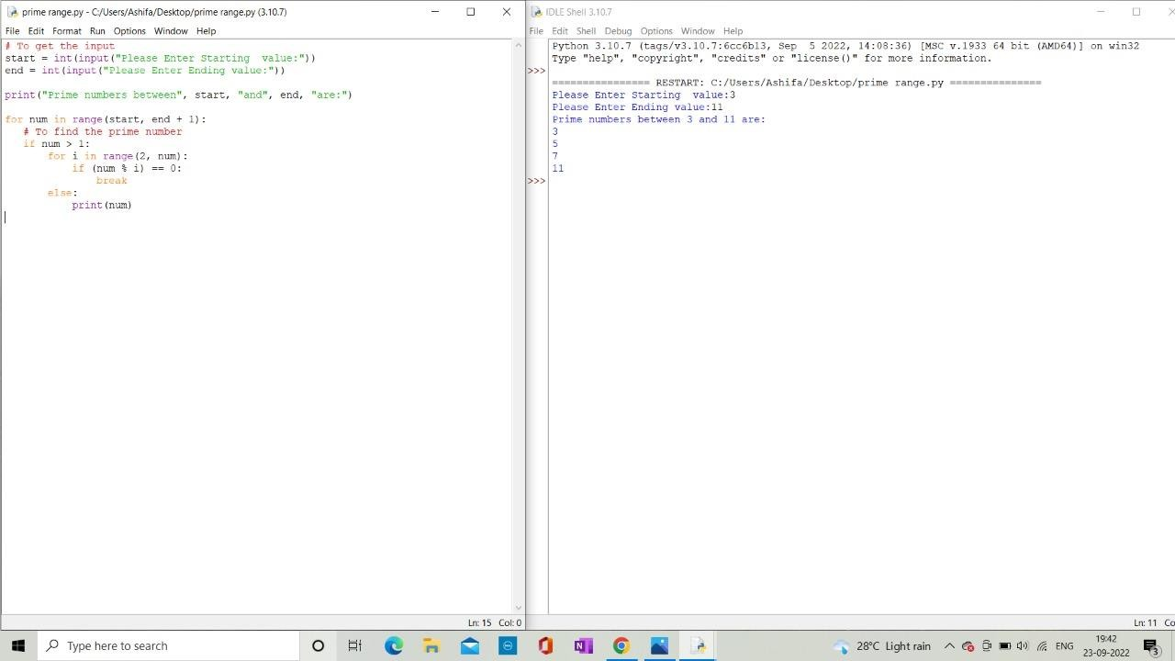

# Question-4:

Write a python program to generate Fibonacci series.

# Solution:

# Program to display the Fibonacci sequence up to n-th term nterms = int(input("How many terms? "))

# first two terms n1, n2 = 0, 1

count = 0

# check if the number of terms is valid if nterms <= 0:

print("Please enter a positive integer") # if there is only one term, return n1

elif nterms == 1:

print("Fibonacci sequence upto",nterms,":") print(n1)

# generate fibonacci sequence else:

print("Fibonacci sequence:") while count < nterms:

print(n1)

nth = n1 + n2

# update values n1 = n2

n2 = nth count += 1

# Output:

Number of inputs:7 Fibonacci series:

0

1

1

2

3

5

8

